**Sponsored by**



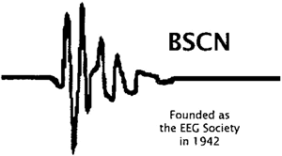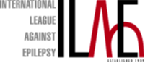**Bursaries by the ILAE & the BSCN**

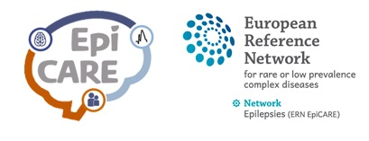**Endorsed by EpiCARE**

This is a 3 ½ day residential EEG course with an emphasis on interactive, hands-on experience. The content covers normal maturational aspects, abnormal EEG patterns and graphoelements in neonates and infants as well as the range of seizures and epilepsies encountered in day-to-day practice in the first year of life. It consists of lectures and practical workshops in small groups guided by one of the faculty tutors.

The course is targeted at pediatric neurologists, clinical neurophysiologists, pediatricians and neonatologist who deal with neonates and infants with seizures or epilepsy. It is limited to 48 participants, so early booking is strongly recommended. Basic EEG knowledge is a requirement for the course and applicants will be selected on the basis of their CVs. We shall be offering a certain number of places for virtual attendance for this course also, but that will not include active interaction in the workshops.

The course is organized under the auspice of the ILAE Academy.

A limited number of bursaries are available on request.

**For more information visit**

https://www.ilae.org/congresses/eeg-in-the-first-year-of-life

🖅 email [neonataleeg@gmail.com](mailto:neonataleeg@gmail.com)

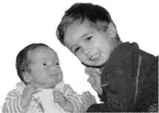

**Feedback from our last courses:**

• One of the best courses I have been to – thank you!

• Both lecture and workshops work well hand in hand.

• Excellent course, very clear presentations – congratulations!!

• Workshops were brilliant, small groups with wonderful tutors.

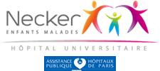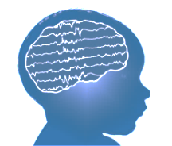

Comprehensive ILAE teaching course with a combination of lectures and expert-led practical sessions

Clare College, Cambridge, UK

10th – 13th April 2022

**EEG in the   
First Year of Life**

**- from newborn to toddler**



**Course directors:**

* **Dr Ronit Pressler**  
  Great Ormond Street Hospital for Children, London, UK
* **Dr Monika Eisermann**Necker Enfants Malades Hospital, Paris, France

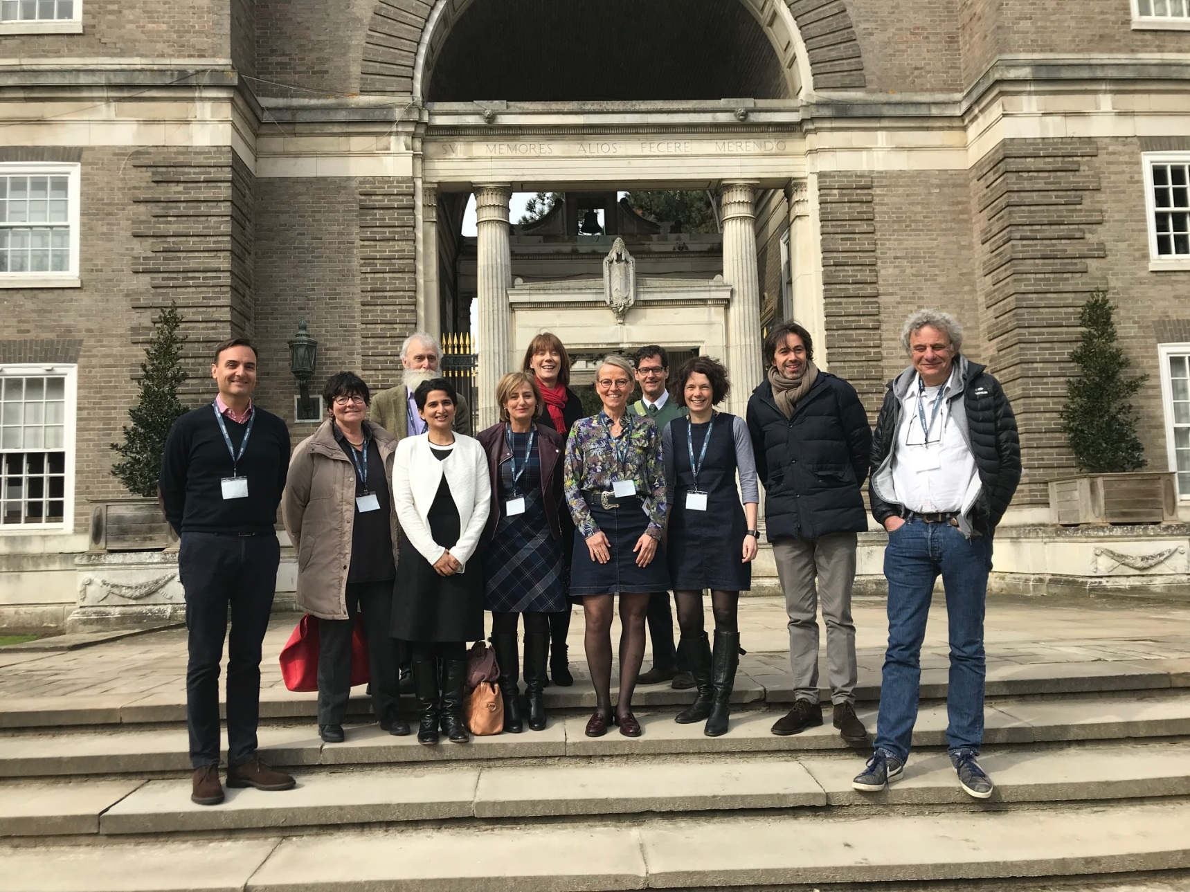

**ILAE Teaching course • EEG in the first year of life – from newborn to toddler • 10-13 April 2022 • Clare College, Cambridge**



**Faculty**

* Dr Ronit Pressler, Great Ormond Street Hospital, London, UK
* Dr Monika Eisermann, Hôpital Necker Enfants Malades, Paris, France
* Prof Geraldine Boylan, University College Cork, Cork, Ireland
* Dr Stewart Boyd, Great Ormond Street Hospital, London, UK
* Prof Alexandre Datta, Basel Children’s Hospital, Basel, Switzerland
* Dr Sushma Goyal, Evelina London Children’s Hospital, London, UK
* Prof Leven Lagae (tbc)
* Dr M Angeles Pérez,Hospital Infantil Niño Jesús, Barcelona, Spain (tbc)
* Prof David Rowitch, University of Cambridge, UK (tbc)
* Prof Nicola Specchio, Ospedale Pediatrico Bambino Gesù, Rome, Italy
* Dr Rachel Thornton, Addenbrookes Hospital, Cambridge, UK
* Prof Federico Vigevano, Bambino Gesu Hospital, Rome, Italy
* Prof Fabrice Wallois, CHU Amiens, INSERM U1105, France

Programme

**Sunday 10 April**

12:00-13:00 Registration and Lunch

13:00-13:30 Alexandre Datta: Technical aspects, challenges, and pitfalls

13:30-14:00 Fabrice Wallois: Normal EEG in pre and term infants

14:00-14:30 Stewart Boyd: Normal EEG in Infancy

14:30-15:00 Alexandre Datta: Sleep – normal and abnormal

15:30-17:30 ***Workshop I*** - Normal EEG in newborns & infants

19:00-20:30 Dinner

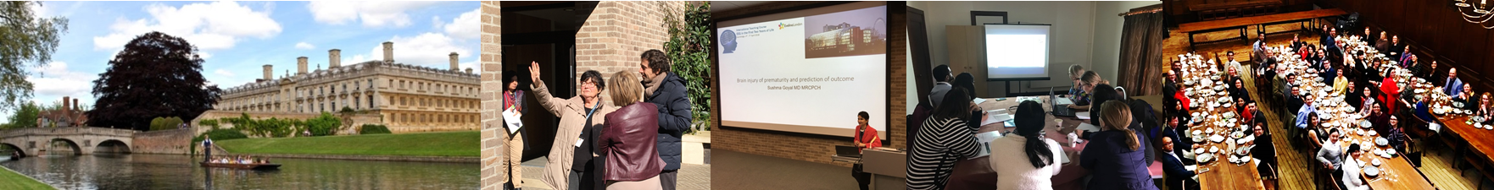

**Monday 11 April**

09:00-09:30 Stewart Boyd: Abnormal EEG in newborns and infants

09:30-10:00 Geraldine Boylan: Brain injury of prematurity & prediction of outcome

10:00-10:30 Sushma Goyal: Hypoxic ischemic encephalopathy

11:00-12:30 ***Workshop II*** - Brain injury in term & preterm infants

13:30-14:30 Ronit Pressler: Neonatal seizures & classification

14:30-15:00 K David H Rowitch: Stratified Approach for Neonatal Seizures

15:30-17:30 ***Workshop III*** - Neonatal seizures

From 19:00 *Social evening – dinner not provided

**Tuesday 12 April**

09:00-09:30 Monika Eisermann: Early onset epileptic encephalopathies

09:30-10:00 Leven Lagae: Hypsarrhythmia and epileptic spasms

10:00-10:30 Federico Vigevano: EEG in genetic disorders

11:00-13:00 ***Workshop IV*** – Epileptic encephalopathies and genetic epilepsies

14:00-14:30 Monika Eisermann: EEG abnormalities in inborn error of metabolism

14:30-15:00 Nicola Specchio: Self-limiting epilepsy syndromes in infancy

15:30-17:00 ***Workshop V*** - IEM and benign epilepsy syndromes

19:00-20:30 Gala Dinner

**Wednesday 13 April**

09:00-09:30 Rachel Thornton: Cortical malformations in infancy

09:30-10:00 María Ángeles Pérez-Jiménez: Non-epileptic events in infancy

10:30-12:30 ***Workshop VI*** – Cortical malformation and other cases

13:30-15:00 ***Workshop VII*** – participants cases

15:00-15:45 Ronit Pressler and Monika Eisermann: Quiz

15:45 END OF COURSE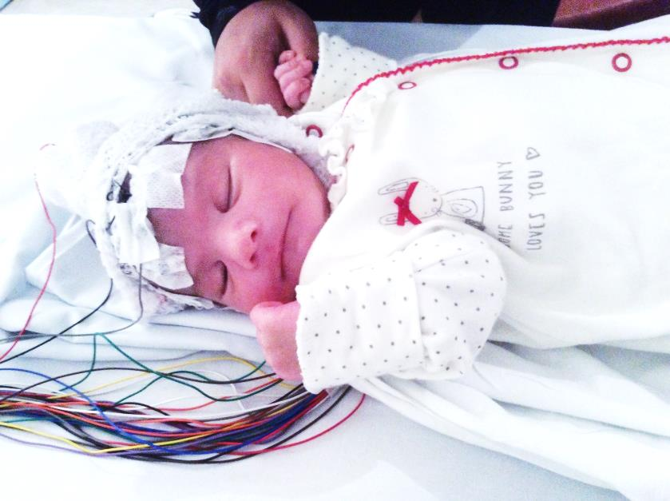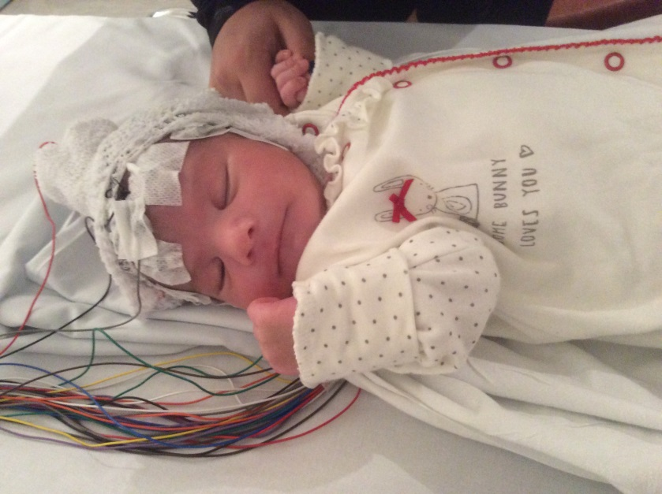

**Registration Fee**

**Early fee $ 1390 (until 31.12.2021)**

**Standard fee $ 1500 (from 01.01.2022)**

**Virtual fee $ 490 (Excludes interactive workshops)**

Includes accommodation at Clare College (3 nights), full board (except dinner on the 11.4.22), Gala dinner on the last evening and access to all educational activities (lectures, workshops, case discussions, course booklet and USB with course material). Extra night accommodation is charged @ $140.